Student Record Management System (C Language)
Objective: Develop a menu-driven application to store, search and display student records.

System Flowchart
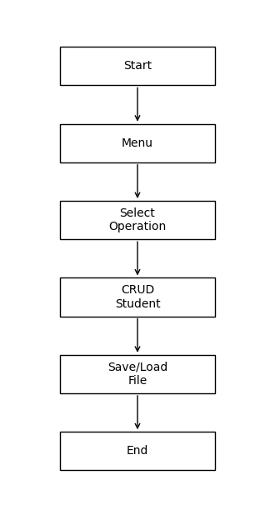

System Diagram
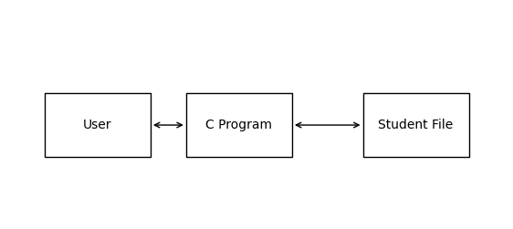

Algorithm
- Start program.
- Display menu.
- Read user's choice.
- If Add: accept student details.
- If Display: print all records.
- If Search: find record by roll number.
- Repeat until Exit.

C Program
#include <stdio.h>
#include <stdlib.h>
struct Student{int roll; char name[50]; float marks;};
int main(){
struct Student s[100]; int n=0,ch,i,r,f;
while(1){
printf("\n1.Add 2.Display 3.Search 4.Exit\n");
scanf("%d",&ch);
if(ch==1){
printf("Roll Name Marks: ");
scanf("%d%s%f",&s[n].roll,s[n].name,&s[n].marks); n++;
} else if(ch==2){
for(i=0;i<n;i++) printf("%d %s %.2f\n",s[i].roll,s[i].name,s[i].marks);
} else if(ch==3){
printf("Enter roll: "); scanf("%d",&r); f=0;
for(i=0;i<n;i++) if(s[i].roll==r){printf("%d %s %.2f\n",s[i].roll,s[i].name,s[i].marks); f=1;}
if(!f) printf("Record not found\n");
} else break;
}
return 0;
}

Sample Output
Sample Output
1.Add 2.Display 3.Search 4.Exit
1
Roll Name Marks:
101 Ayush 91.5
1.Add 2.Display 3.Search 4.Exit
2
101 Ayush 91.50

Conclusion
The project demonstrates basic file/record management concepts using structures, arrays, and menu-driven programming in C.

